**Project Design Phase-II**

**Data Flow Diagram & User Stories**

|  |  |
| --- | --- |
| Date | 21-October 2022 |
| Team ID |  |
| Project Name | Sugarcane production Analysis |
| Maximum Marks | 4 Marks |

**Data Flow Diagrams:**

A Data Flow Diagram (DFD) is a traditional visual representation of the information flows within a system. A neat and clear DFD can depict the right amount of the system requirement graphically. It shows how data enters and leaves the system, what changes the information, and where data is stored.

**Example:** 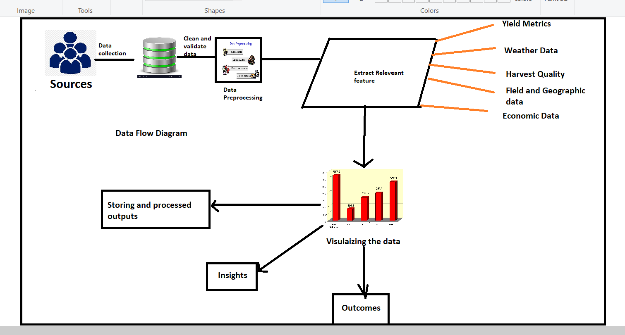

**User Stories**

Use the below template to list all the user stories for the product.

| **User Type** | **Functional Requirement (Epic)** | **User Story Number** | **User Story / Task** | **Acceptance criteria** | **Priority** | **Release** |
| --- | --- | --- | --- | --- | --- | --- |
| Custome (Meobile user) | Registration | USN-1 | As a user, I can register for the application by entering my email, password, and confirming my password. | I can access my account / dashboard | High | Sprint-1 |
|  |  | USN-2 | As a user, I will receive confirmation email once I have registered for the application | I can receive confirmation email & click confirm | High | Sprint-1 |
|  |  | USN-3 | As a user, I can register for the application through Facebook | I can register & access the dashboard with Facebook Login | Low | Sprint-2 |
|  |  | USN-4 | As a user, I can register for the application through Gmail |  | Medium | Sprint-1 |
|  | Login | USN-5 | As a user, I can log into the application by entering email & password |  | High | Sprint-1 |
|  | Dashboard |  |  |  |  |  |
| Customer (Web user) |  | USN-6 | As a user, I can view a summary of my sugarcane production data on the dashboard, including yield, weather conditions, and quality metrics | The dashboard displays an overview of sugarcane production metrics, and I can easily access this information | High | Sprint-2 |
|  |  | USN-7 | As a user, I can filter and customize the dashboard to view specific data, such as historical data, regional comparisons, or specific sugarcane fields. | The dashboard provides options to filter and customize the displayed data, and the changes are reflected in real-time. | Medium | Sprint -3 |
| Customer (Web user) |  | USN-8 | As a web user, I can access the same dashboard features as the mobile user, including viewing production data, filtering options, and customizing my dashboard view. | The web dashboard offers the same functionality as the mobile dashboard, ensuring a consistent user experience. | High | Sprint-2 |
| Customer Care Executive | Support | USN-9 | As a customer care executive, I can access a support portal to assist users with their questions and issues. | The support portal is accessible, and I can view and respond to user queries, providing helpful assistance. | High | Sprint-3 |